Note on Sample Design and Estimation Procedure of NSS 70th Round

1. Introduction

1.1 The National Sample Survey (NSS), set up by the Government of India in 1950 to collect socio-economic data employing scientific sampling methods, started its seventieth round from 1st January 2013. The survey will continue up to 31st December 2013.

1.2 Subject Coverage: The 70th round (January 2013 - December 2013) of NSS is earmarked for surveys on land and livestock holdings, debt and investment and situation assessment survey of agricultural households. The last survey on these subjects was conducted in 59th round of NSS (January 2003 - December 2003).

2. Outline of Survey Programme

2.1 Geographical coverage: This survey covers the whole of the Indian Union.

2.2 Visits 1 & 2: Each sample FSU is being visited twice during this round. Since the workload of the first visit (i.e. visit 1) is more, the first visit continues till the end of July 2013. Thus, period of the first visit is January – July 2013 and that of the second visit (i.e. visit 2) is August – December 2013.

The listing schedules (sch 0.0) are canvassed only in the first visit. Schedules 18.1, 18.2 and 33 are canvassed in independent sets of sample households. Each sample household is visited twice. Visit 1 and visit 2 schedules are to be canvassed in the same set of sample households during first and second visit respectively. Contents of the schedules for the two visits are not same since the information relate to two different seasons.

2.3 Sub-rounds: The survey period of the round are divided into two sub-rounds. Sub-round one will consist of the first half of the survey period of each visit i.e. 1st Jan -15th April 2013 for visit 1 and 1st August – 15th October 2013 for visit 2 while sub-round two consists of the remaining period of the respective visits. Thus, each sub-round are three and a half months for visit 1 and two and a half months for visit 2.

In each of these two sub-rounds equal number of sample villages/ blocks (FSUs) are allotted for survey with a view to ensuring uniform spread of sample FSUs over the entire survey period. Attempt will be made to survey each of the FSUs during the sub-round to which it is allotted. Because of the arduous field conditions, this restriction need not be strictly enforced in Andaman and Nicobar Islands, Lakshadweep and rural areas of Arunachal Pradesh and Nagaland.
The villages/blocks visited in the first sub-round of first visit is being revisited during the first sub-round of the second visit. Similarly, villages/blocks of sub-round 2 of visit 1 to be revisited in sub-round 2 of visit 2.

2.4 Schedules of enquiry: During this round, the following schedules of enquiry are being canvassed:

Schedule 0.0 : | list of households
Schedule 18.1 : | land and livestock holdings (rural only)
Schedule 18.2 : | debt and investment
Schedule 33 : | situation assessment survey of agricultural households (rural only)

2.5 Participation of States: In this round all the States and Union Territories except Andaman & Nicobar Islands, Chandigarh, Dadra & Nagar Haveli and Lakshadweep are participating. The following is the matching pattern of the participating States/ UTs.

Nagaland (U) | : triple
Andhra Pradesh, J & K , Manipur | : double
Maharashtra (U) | : one and half
Remaining States/ UTs | : equal

3. Sample Design

3.1 Outline of sample design: A stratified multi-stage design has been adopted for the 70th round survey. The first stage units (FSU) are the census villages (Panchayat wards in case of Kerala) in the rural sector and Urban Frame Survey (UFS) blocks in the urban sector. The ultimate stage units (USU) are households in both the sectors. In case of large FSUs, one intermediate stage of sampling is the selection of two hamlet-groups (hgs)/ sub-blocks (sbs) from each rural/ urban FSU.

3.2 Sampling Frame for First Stage Units: For the rural sector, the list of 2001 census villages updated by excluding the villages urbanised and including the towns de-urbanised after 2001 census (henceforth the term ‘village’ would mean Panchayat wards for Kerala) constitutes the sampling frame. For the urban sector, the latest updated list of UFS blocks (2007-12) is considered as the sampling frame.

3.3 Stratification:

- Stratum has been formed at district level. Within each district of a State/ UT, generally speaking, two basic strata have been formed: i) rural stratum comprising of all rural areas of the district and (ii) urban stratum comprising all the urban areas of the district. However, within the urban areas of a district, if there were one or more towns with population 10 lakhs or more as per population census 2011 in a district, each of them formed a separate basic stratum and the remaining urban areas of the district was considered as another basic stratum.

- However, a special stratum in the rural sector only was formed at State/UT level before district- strata were formed in case of each of the following 20 States/UTs: Andaman & Nicobar Islands, Andhra Pradesh, Assam, Bihar, Chhattisgarh, Delhi, Goa, Gujarat, Haryana, Jharkhand, Karnataka, Lakshadweep, Madhya Pradesh, Maharashtra, Odisha, Punjab, Rajasthan, Tamil Nadu, Uttar Pradesh and West Bengal. This stratum will comprise all the villages of the State with population less than 50 as per census 2001.

- In case of rural sectors of Nagaland one special stratum has been formed within the State consisting of all the interior and inaccessible villages. Similarly, for Andaman & Nicobar Islands, one more special stratum has been formed within the UT consisting of all inaccessible villages. Thus for Andaman & Nicobar Islands, two special strata have been formed at the UT level:

- special stratum 1 comprising all the interior and inaccessible villages
- special stratum 2 containing all the villages, other than those in special stratum 1, having population less than 50 as per census 2001.

3.4 Sub-stratification:

Rural sector: Different sub-stratifications are done for ‘hilly’ States and other States. Ten (10) States are considered as hilly States. They are: Jammu & Kashmir, Himachal Pradesh, Uttarakhand, Sikkim, Meghalaya, Tripura, Mizoram, Manipur, Nagaland and Arunachal Pradesh.

(a) sub-stratification for hilly States: If ‘r’ be the sample size allocated for a rural stratum, the number of sub-strata formed was ‘r/2’. The villages within a district as per frame have been first arranged in ascending order of population. Then sub-strata 1 to ‘r/2’ have been demarcated in such a way that each sub-stratum comprised a group of villages of the arranged frame and have more or less equal population.

(b) sub-stratification for other States (non-hilly States except Kerala): The villages within a district as per frame were first arranged in ascending order of proportion of irrigated area in the cultivated area of the village. Then sub-strata 1 to ‘r/2’ have been demarcated in such a way that each sub-stratum comprised a group of villages of the arranged frame and have more or less equal cultivated area. The information on irrigated area and cultivated area was obtained from the village directory of census 2001.

(c) sub-stratification for Kerala: Although Kerala is a non-hilly State but because of non-availability of information on irrigation at FSU (Panchayat Ward) level, sub-stratification by proportion of irrigated area was not possible. Hence the procedure for sub-stratification was same as that of hilly States in case of Kerala.

Urban sector: There was no sub-stratification for the strata of million plus cities. For other strata, each district was divided into 2 sub-strata as follows:

sub-stratum 1: all towns of the district with population less than 50000 as per census 2011
sub-stratum 2: remaining non-million plus towns of the district

3.5 Total sample size (FSUs): 8042 FSUs have been allocated for the central sample at all-India level. For the state sample, there are 8998 FSUs allocated for all-India. State wise allocation of sample FSUs is given in Table 1.

3.6 Allocation of total sample to States and UTs: The total number of sample FSUs have been allocated to the States and UTs in proportion to population as per census 2011 subject to a minimum sample allocation to each State/ UT. While doing so, the resource availability in terms of number of field investigators as well as comparability with previous round of survey on the same subjects has been kept in view.

3.7 Allocation of State/ UT level sample to rural and urban sectors: State/ UT level sample size has been allocated between two sectors in proportion to population as per census 2011 with double weightage to urban sector subject to the restriction that urban sample size for bigger states like Maharashtra, Tamil Nadu etc. should not exceed the rural sample size. A minimum of 16 FSUs (minimum 8 each for rural and urban sector separately) is allocated to each state/ UT.

3.8 Allocation to strata: Within each sector of a State/ UT, the respective sample size has been allocated to the different strata in proportion to the population as per census 2011. Allocations at stratum level are adjusted to multiples of 2 with a minimum sample size of 2.

For special stratum formed in the rural areas of 20 States/UTs, as discussed in para 3.3 (b), 2 FSUs were allocated to each.

For special stratum 1 in the rural areas of Nagaland and Andaman & Nicobar Islands, 4 and 2 FSUs were allocated respectively.

3.9 Allocation to sub-strata:

3.9.1 Rural: Allocation is 2 for each sub-stratum in rural.

3.9.2 Urban: Stratum allocations have been distributed among the two sub-strata in proportion to the number of FSUs in the sub-strata. Minimum allocation for each sub-stratum is 2.
3.10 Selection of FSUs:

For the rural sector, from each stratum x sub-stratum, required number of sample villages has been selected by Simple Random Sampling Without Replacement (SRSWOR).

For the urban sector, FSUs have been selected by using Simple Random Sampling Without Replacement (SRSWOR) from each stratum x sub-stratum.

Both rural and urban samples were drawn in the form of two independent sub-samples and equal number of samples has been allocated among the two sub rounds.

3.11 Selection of hamlet-groups/ sub-blocks - important steps

3.11.1 Criterion for hamlet-group/ sub-block formation: After identification of the boundaries of the FSU, it is first determined whether listing is to be done in the whole sample FSU or not. In case the approximate present population of the selected FSU is found to be 1200 or more, it is divided into a suitable number (say, D) of ‘hamlet-groups’ in the rural sector and ‘sub-blocks’ in the urban sector by more or less equalising the population as stated below.

approximate present population of the sample FSU | no. of hg’s/sb’s to be formed
less than 1200 (no hamlet-groups/sub-blocks) | 1
1200 to 1799 | 3
1800 to 2399 | 4
2400 to 2999 | 5
3000 to 3599 | 6
…………..and so on | .

For rural areas of Himachal Pradesh, Sikkim, Uttarakhand (except four districts Dehradun, Nainital, Hardwar and Udham Singh Nagar), Poonch, Rajouri, Udhampur, Reasi, Doda, Kistwar, Ramgarh, Leh (Ladakh), Kargil districts of Jammu and Kashmir and Idukki district of Kerala, the number of hamlet-groups are formed as follows:

approximate present population of the sample village | no. of hg’s to be formed
less than 600 (no hamlet-groups) | 1
600 to 899 | 3
900 to 1199 | 4
1200 to 1499 | 5
1500 to 1799 | 6
.………..and so on | .

3.11.2 Formation and selection of hamlet-groups/ sub-blocks: In case hamlet-groups/ sub-blocks are to be formed in the sample FSU, the same is done by more or less equalizing population. While doing so, it is ensured that the hamlet-groups/ sub-blocks formed are clearly identifiable in terms of physical landmarks.

Two hamlet-groups (hg)/ sub-blocks (sb) are selected from a large FSU wherever hamlet-groups/ sub-blocks have been formed in the following manner – one hg/ sb with maximum percentage share of population is always selected and termed as hg/ sb 1; one more hg/ sb is selected from the remaining hg’s/ sb’s by simple random sampling (SRS) and termed as hg/ sb 2. Listing and selection of the households is done independently in the two selected hamlet-groups/ sub-blocks.

3.12 Formation of second stage strata and allocation of households

3.12.1 Schedule 18.1: Land & Livestock Holdings Survey (LHS) (rural only):

Four SSS are formed for schedule 18.1 based on four land possessed codes. SSS number is same as the land possessed code.

Each household has been given a land possessed code according to the following criteria:

land possessed code | criterion: area of the land possessed by the household  as on the date of survey
1 | less than 0.005 hectare
2 | equal to or more than 0.005 hectare but less than 1.000 hectare
3 | equal to or more than 1.000 hectare but less than 2.000 hectares
4 | equal to or more than 2.000 hectares

3.12.2 Schedule 33: Situation Assessment Survey of Agricultural Households (SAS) (rural only):

Only ‘agricultural households’ are considered for this schedule. The agricultural households have been divided into four SSS based on land possessed codes similar to LHS second stage strata.
3.12.3 Schedule 18.2: Debt and Investment Survey (AIDIS):

Three SSS are formed both in rural and urban sector: (i) households indebted either to institutional agencies only or to both institutional and non-institutional agencies, (ii) households indebted to non-institutional agencies only and (iii) households without any indebtedness.

3.12.4 Allocation and selection of sample households: The total number of households to be surveyed in an FSU is given below for each schedule type:

Two households have been selected from each SSS for schedule 18.1 and 33. In case of hamlet group formation, one household is to be selected from each hg × SSS for schedule 18.1 and 33. For schedule 18.2, the number of sample households are 6, 4 and 4 from SSS 1, 2 and 3 respectively. In case of hamlet group/sub-block formation, the number of sample households are 3, 2 and 2 from each (hg/sb) x SSS for schedule 18.2. The number of SSS, allocations and sampling scheme by schedule type are illustrated in the following table.

schedule type | number of SSS | number of sample households to be surveyed
schedule type | number of SSS | rural | urban | sampling scheme within each SSS
18.1 | 4 | 8  (2 households from each SSS) | ---- | SRSWOR
18.2 | 3 | 14  (SSS1 = 6, SSS2 = 4, SSS3 = 4) | 14  (SSS1 = 6, SSS2 = 4, SSS3 = 4) | SRSWOR
33 | 4 | 8  (2 households from each SSS) | ---- | SRSWOR

3.12.5 Selection of households: From each SSS the sample households for each of the schedules are selected by SRSWOR.

4. Estimation Procedure

4.1 Notations:

s = subscript for s-th stratum
t = subscript for t-th sub-stratum
m = subscript for sub-sample (m =1, 2)
i = subscript for i-th FSU [village (panchayat ward)/ block]
d = subscript for a hamlet-group/ sub-block (d = 1, 2)
j = subscript for j-th second stage stratum in an FSU/ hg/sb
k = subscript for k-th sample household under a particular second stage stratum within an FSU/ hg/sb
D = total number of hg’s/ sb’s formed in the sample FSU
D* = 0 if D = 1
= (D – 1) for FSUs with D > 1
N = total number of FSUs in any rural/urban sub-stratum
n = number of sample FSUs surveyed including ‘uninhabited’ and ‘zero cases’ but excluding casualty for a particular sub-sample and sub-stratum.
H = total number of households listed in a second-stage stratum of an FSU / hamlet-group or sub-block of sample FSU
h = number of households surveyed in a second-stage stratum of an FSU / hamlet-group or sub-block of sample FSU
x, y = observed value of characteristics x, y under estimation
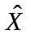, = estimate of population total X, Y for the characteristics x, y

Under the above symbols,

y_{stmidjk} = observed value of the characteristic y for the k-th household in the j-th second stage stratum of the d-th hg/ sb (d = 1, 2) of the i-th FSU belonging to the m-th sub-sample for the t-th sub-stratum of s-th stratum.

However, for ease of understanding, a few symbols have been suppressed in following paragraphs where they are obvious.

4.2 Formulae for Estimation of Aggregates for a particular sub-sample and stratum × sub-stratum:

4.2.1 Schedule 0.0:

4.2.1.1 Rural / Urban:

- For estimating the number of households in a stratum × sub-stratum possessing a characteristic:
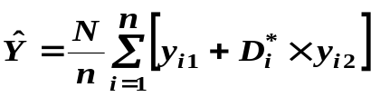
where 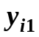 , 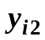 are the total number of households possessing the characteristic y in hg’s/sb’s 1 & 2 of the i-th FSU respectively.

(ii) For estimating the number of villages in a stratum × sub-stratum possessing a characteristic:
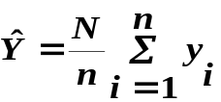
where 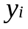 is taken as 1 for sample villages possessing the characteristic and 0 otherwise.

4.2.2 Schedules 18.1 / 18.2 / 33:

4.2.2.1 Rural/Urban:

- For j-th second stage stratum:

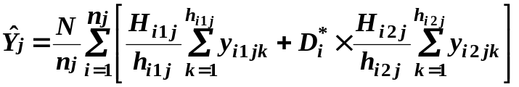

- For all second-stage strata combined:

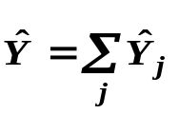

Note: i) Schedule 18.1 and 33 has been canvassed in rural sector only
ii) Values of j for different schedules are as follows:

for sch. 18.1, j = 1, 2, 3 or 4;
for sch. 18.2, j = 1, 2 or 3 and
for sch. 33, j = 1, 2, 3 or 4

4.2.2.2 Estimates in respect of joint operational holdings: In the case of joint operational holdings operated by the sample household jointly with other household(s), the value of a characteristic of the operational holding will be first multiplied by the percentage share of land of the sample household(s) and then the higher estimates will be built up.

4.3 Overall Estimate for Aggregates for a sub-stratum:
Overall estimate for aggregates for a sub-stratum (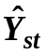) based on two sub-samples is obtained as:
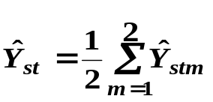

4.4 Overall Estimate for Aggregates for a stratum:

Overall estimate for a stratum (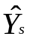) will be obtained as

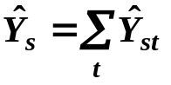

4.5 Overall Estimate of Aggregates at State/UT/all-India level:

The overall estimate 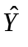at the State/ UT/ all-India level is obtained by summing the stratum estimates 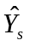over all strata belonging to the State/ UT/ all-India.

4.6 Estimates of Ratios:

Let and 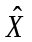 be the overall estimates of the aggregates Y and X for two characteristics y and x respectively at the State/ UT/ all-India level.
Then the combined ratio estimate 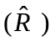of the ratio 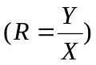 will be obtained as 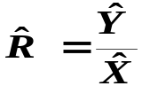.

4.7 Estimates of Error: The estimated variances of the above estimates will be as follows:

4.7.1 For aggregate : 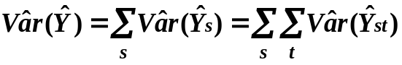 where 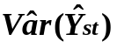 is given by

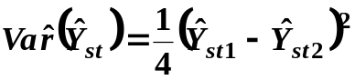, where 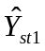 and 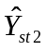 are the estimates for sub-sample 1 and sub-sample 2 respectively for stratum ‘s’ and sub-stratum ‘t’.

4.7.2 For ratio 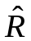:

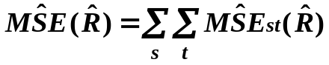 where 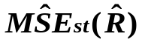 is given by

4.7.3 Estimates of Relative Standard Error (RSE):

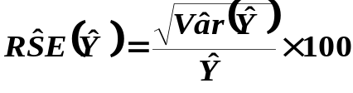
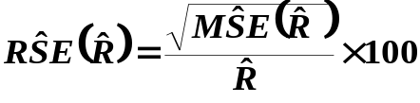

5. Multipliers:

5(a) Two sets of multipliers may be generated:

- For visit 1 only
- For visit 2 only

Hence, household multiplier will be equal to:

- visit 1 multiplier for all estimation based only on the visit 1 households
- visit 2 multiplier for all estimation based only on the visit 2 households
- visit 2 multiplier for generating combined estimates based on the common set of households of visit 1 and visit 2.

5(b) The formulae for multipliers at stratum/sub-stratum/second-stage stratum for a sub-sample and schedule type are given below:

sch type | sector | formula for multipliers
sch type | sector | hg / sb 1 |  | hg / sb 2
0.0 | rural / urban | 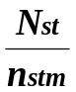 |  | 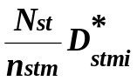
18.1 / 33 | rural | 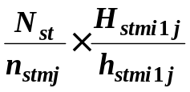 |  | 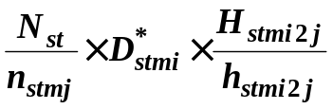
18.1 / 33 | ( j = 1, 2, 3, 4)
18.2 | rural / urban
18.2 | ( j = 1, 2, 3)

Note: (i) For estimating any characteristic for any domain not specifically considered in sample design, indicator variable may be used.
(ii) Multipliers have to be computed on the basis of information available in the listing schedule irrespective of any misclassification observed between the listing schedule and detailed enquiry schedule.
(iii) For estimating number of villages possessing a characteristic, 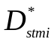 = 0 in the relevant multipliers and there will be only one multiplier for the village.

6. Treatment for zero cases, casualty cases etc.:

6.1 While counting the number of FSUs surveyed (n_{stm}) in a stratum x sub-stratum, all the FSUs with survey codes 1 to 6 in schedule 0.0 will be considered. In addition, if no SSU is available in the frame for a particular schedule then also that FSU will be treated as surveyed in respect of that schedule. However, if the SSUs of a particular schedule type are available in the frame of the FSU but none of these could be surveyed then that FSU has to be treated as casualty and it will not be treated as surveyed in respect of that schedule.

6.2 Casualty cases: FSUs with survey code 7 as per schedule 0.0 are treated as casualties. In addition to this, an FSU, although surveyed, may have to be treated as casualty for a particular schedule type and a particular second stage stratum as given in the following para:

6.2.1 FSUs with survey codes 1 or 4 as per schedule 0.0 having number of households in the frame of j-th second stage stratum greater than 0 but number of households surveyed according to data file, considering both hg/sb together, as nil (i.e. H_{i1j} + H_{i2j} >0 but h_{i1j} + h_{i2j} =0) will be taken as casualties for j-th second stage stratum.

All the FSUs with survey codes 1 to 6 as per schedule 0.0 minus the number of casualties as identified above will be taken as the number of surveyed FSUs (n_{stmj} ) for that (stratum x sub-stratum) × ( second stage stratum).

When casualty for j-th second stage stratum occurs for a particular hg/sb but not for the other hg/sb, the FSU will not be treated as casualty but some adjustments in the value of H for the other hg/sb will be done as follows:

- Suppose for hg/sb 1, H_{i1j} > 0 but h_{i1j} = 0 while for hg/sb 2, H_{i2j} > 0 and h_{i2j} > 0. In that case 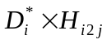 will be replaced by 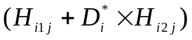 in the formula for multiplier of hg/sb 2.

(ii) Suppose for hg/sb 1, H_{i1j}>0 and h_{i1j} > 0 while for hg/sb 2, H_{i2j}>0 but h_{i2j}=0. In that case 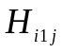 will be replaced by in the formula for multiplier of hg/sb 1.
It may be noted that n_{stmj} would be same for hg/sb 1 & 2 of an FSU.

7. Treatment in cases of void second-stage strata/sub-strata/strata/NSS region at FSU or household level

7.1 A stratum/sub-stratum may be void because of the casualty of all the FSUs belonging to the stratum/sub-stratum. This may occur in one sub-sample or in both the sub-samples. If it relates to only one sub-sample, then estimate for the void stratum/sub-stratum may be replaced with the estimate as obtained from the other sub-sample for the same stratum/sub-stratum.

7.2 When a stratum/sub-stratum is void in both the sub-samples, the following procedure is recommended:

Case(I): Stratum/Sub-stratum void cases at FSU levels (i.e. all FSUs having survey code 7):

- If a rural sub-stratum is void then it may be merged with the other sub-stratum of the stratum.
- If a rural/urban stratum (district) is void due to all FSUs being casualty, it may be excluded from the coverage of the survey. The state level estimates will be based on the estimates of districts for which estimates are available and remarks to that effect may be added in appropriate places.

Case (II): Stratum/Sub-stratum void case at second stage stratum level (i.e. all the FSUs are casualties for a particular second stage stratum):

An FSU may be a casualty for a particular second stage stratum although survey code is not 7. If all the FSUs of a sub-stratum become casualties in this manner for a particular second stage stratum, the sub-stratum will become void. In such cases, sub-strata will be merged with other sub-strata for all the second stage strata as in Case (I) above.

However, if whole district/stratum becomes void in this manner for a particular second stage stratum, adjustment for this type of stratum void case may be done according to the following guidelines.
The adjustment will be made involving other strata (within NSS region) of the State/U.T. Suppose A, B, C and D are the four strata in the State/UT/Region and stratum C is void for j-th second stage stratum. If 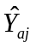, 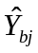and 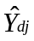are the aggregate estimates for the strata/sub-strata A, B and D respectively, then the estimate 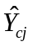 for stratum C may be obtained as 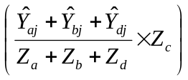where Z_{a}, Z_{b}, Z_{c} and Z_{d} are the sizes of strata A, B, C and D respectively.

8. Reference to the values of N_{s}, n_{st}, n_{s,} D_{sti}, D*_{sti}, D_{si}, D*_{si}, H_{sti1j}, h_{sti1j}, H_{sti2j}, h_{sti2j:}

- Value of N_{st} and allotted n_{st} for the whole round are given in appendix Table 2 for rural sector and in Table 3 for urban sector.
- n_{st} should not be taken from the tables. The values of n_{stm} for each sub-sample are to be obtained following the guidelines given in para 6 above. It includes uninhibited and zero cases but excludes casualty cases.
- Value of D_{sti} is to be taken from item 16 of block 1, sch 0.0. D*_{sti} is to be calculated from the value of D_{sti}.
- Values of H_{sti1j}, H_{sti2j} are to be taken from col.(5), block 6 of sch 0.0 for respective hg/sb and second-stage stratum.
- The value of h_{sti1j} and h_{sti2j} should not be taken from col (9), block 6 of Sch. 0.0. The figures should be obtained by counting the number of households in the data file excluding the casualty households.

